**CHAPTER 1**

**INTRODUCTION**

In today’s busy world, where even every micro second is considered as very significant, almost all existing systems can be considered as real time systems because time has become a very important factor for execution of any system. The present communication systems such as WiMAX, Bluetooth are also providing real time communication but it has range problem as well as they are not very secure. The wireless technologies have gained lots of importance because of fast speed, security and low-cost. While have attempted real-time audio & video transmission system based on visible light communication but it has range limitations of just three meters. have proposed android based platform to use the advantage of Wi-Fi systems, for peer to peer calling and group calling using free resources and standards to keep the cost low. we are transmitting audio to a remote location. For transmitting the voice through the raspberry pi VOIP means voice over IP technique is used. Which help us to transmit the voice over the one IP address to other IP address in same network as well as other networks also.

The raspberry pi is a low cost, credit-card sized computer that plugs into a computer monitor or TV and uses a standard keyboard and mouse. It is capable of doing all those things that a PC can do, right from browsing the internet and playing high definition video, to make spreadsheets, word- processing and playing games. The user can select the Public address system using Wi-Fi modem. The APP is in the network connected to all the slaves. The APP is used to select the Unit through which the Public address system is governed. The user can select any one of the slaves or both the slaves at the same time. Once the Unit is selected the Raspberry Pi will channel the I/P through the Speaker. The all device is connected to some network and it will help the all system to work efficient and smoothly. This Network base PA System is covering the lager area in the some as well as different networks.

* 1. **Voice Over WLA**

Voice over wireless LAN is the use of a wireless broadband network according to the IEEE 802.11 standards for the purpose of vocal conversation. In essence, it is voice over IP (VoIP) over a Wi-Fi network. In most cases, the Wi-Fi network and voice components supporting the voice system are privately owned. For a single location organization, it enables use of existing Wi-Fi network for low, or no, cost of use VoIP communication in a similar manner to land mobile radio system or walkie-talkie systems with push to talk and emergency broadcast channels. There are also use across multiple locations for mobile workers such as delivery drivers, these workers need to take advantage of 3G type services whereby a cellular company provide data access between the handheld device and the companies back-end network. A voice over WLAN system offers several benefits to organizations, such as hospitals and warehouses. Such advantages include increased mobility and cost savings. For instance, nurses and doctors within a hospital can maintain voice communications at any time at less cost, compared to cellular service. This Network base PA System is covering the lager area in the some as well as different networks.

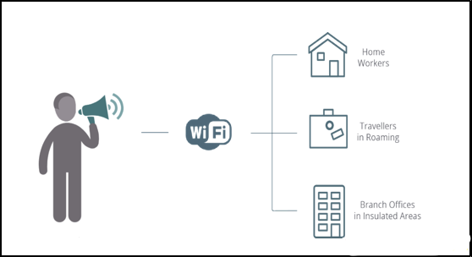

**Figure1.1: Voice over Wi-Fi**

A Wi-Fi network that supports voice telephony must be carefully designed in a way that maximizes performance and is able to support the applicable call density. A voice network includes call gateways in addition to the Wi-Fi access points. The gateways provide call handling among wireless IP phones and connections to traditional telephone systems. The Wi-Fi network supporting voice applications must provide much stronger signal coverage than what’s needed for most data-only applications. In addition, the Wi-Fi network must provide seamless roaming between access points.

**1.2 Project Overview**

Network Based Wireless Public Address (PA) system is important in our daily live. This system usually found at the public area likes bus station, supermarket and hospital. The main purpose of this system is to inform the people about anything. At the bus station for example, the public address system main purpose is to inform the passenger about the bus information and their journey information. The traditional Public Address system is using the electronic circuit and it is manually control by human. It need full attention to make the system work efficiently. In this project, a new Public Address system using wireless connection with a complete Graphical User Interface (GUI) to inform the departure and arriving of busses to nearby cell phone using Bluetooth wireless connection. This fully automatic system will scan nearby busses, check the details about the bus information and send the information to nearby Bluetooth hand phones. The information will be send on demand of the users or passenger. The details about this project will be explained in this report.

**1.3 Objective**

The main objective of our proposed system is The present communication systems such as Wi-Fi, Bluetooth are also providing real time communication but it has range problem as well as they are not very secure. The wireless technologies have gained lots of importance because of fast speed, security and low-cost. That all problem overcome in our project. The main objective is to transmit the users voice over long distance in real time with the help of Wi-Fi network and it will help to transmit data over a long distance. This all process will on real time so there is noise will reduce and the voice clarity will increase. With the help of Logitech server media the voice over the network will possible to transmit the user voice in real time. Develop a fully working wireless PA system to be use at the bus station to inform the departure and arriving of the busses to the mobile phone.

**1.4 Relevance**

Nowadays, the demand for the Wi-Fi connection is highly compare to other wireless connections. The Wi-Fi device become a basic specification in newest electronic devices likes laptop computer, mobile phone and even the head unit in car entertainment. This make over 1 billion Wi-Fi device sold each year. This gives the opportunities to the software developer to develop the application for the Wi-Fi wireless connection. This project will explain how to build the application using Wi-Fi application using Java and Linux.

**1.5 Scope**

**T**he scopes of the project are as the following:

1. To flow system to develop a programming language.
2. To understand the for the PA system and application in hand phone GUI.
3. To gain the programming and App for mobile.
4. To understand how to work with Raspberry pi.
5. To understand ICEcast 2.
6. To know about the VOIP tech.
   1. **Organization of Report**

Chapter 1 Introduction

Chapter 2 Literature survey of tools used in proposed system.

Chapter 3 Describe the implementation of the PA Systems

Chapter4 Describes the Hardware used for implementation of Network Based Wireless PA System.

Chapter 5 describes the software used for implementation of Network Based Wireless PA System.

Chapter 6 gives a description of the all process, and about how this method is used in system.

Chapter 7Describe the summary and references with component detail an costing of used components.

**CHAPTER 2**

**LITERATURE SURVEY**

A public address system comprises electrical equipment to greatly amplify a speaker's voice so it will reach a much larger assemblage than he could speak to unaided. Beginning with the presidential conventions of the two major parties in 1920 and the inaugural address of President Harding in March 1921, when a special address system installed by the telephone engineers enabled him to address an audience estimated at 125,000, there followed in rapid succession, many public events demonstrating the value of such systems. One of the most notable of these occurred on Armistice Day 1921, when the speeches, prayers and music at Arlington, Virginia, were heard, not only by 100,000 persons gathered there at the National Cemetery, but by some 35,000 in New York City and 20,000 in San Francisco. On this occasion the three public address systems, one for each of these cities, were joined by long distance telephone circuits.

The fundamental requirements of a satisfactory public address system are naturalness of reproduction and wide range of output volume. The meeting of these two requirements for music proves more difficult than for speech. The pick-up device whether of the carbon microphone variety or a condenser transmitter need not be placed close to the speaker's lips but will operate satisfactorily when four or five feet away. The loud-speaking receiver mechanism is so designed that it will carry a power of several watts with small distortion. Under normal conditions, 40 watts distributed among a number of receiver-projectors arranged in a circle is ample to reach an audience of 700,000 persons. Digital PA Control Unit The digital PA control unit is adopted with digital two- way transmission system in a single cable connection. That reduces the installation time as well as makes the installing easier and repairing faster. A digital PA control unit can support maximum 64 single zones, 8 grouping zones broadcasting by real hardware implementation. It can be equipped with 8-CH input mixer. Moreover, if the broadcasting zones are more than 64 zones, thus, we can also extend to 192 zones and 24 control groups by using dedicated control software method for reducing the cost of hardware. Moreover, it can support wire-breaking detection also.

The simplest, smallest PA systems consist of a microphone, an amplifier, and one or more loudspeakers. PA systems of this type, often providing 50 to 200 watts of power, are often used in small venues such as school auditoriums, churches, and coffeehouse stages. Small PA systems may extend to an entire building, such as a restaurant, store, elementary school or office building. A sound source such as a compact disc player or radio may be connected to a PA system so that music can be played through the system. Smaller, battery-powered 12 volt systems may be installed in vehicles such as tour buses or school buses, so that the tour guide and/or driver can speak to all the passengers. Portable systems may be battery powered and/or powered by plugging the system into an electric wall socket. These may also be used for by people addressing smaller groups such as information sessions or team meetings. Battery-powered systems can be used by guides who are speaking to clients on walking tours.Public address systems consist of input sources microphones, sound playback devices, amplifiers, control and monitoring equipment LED indicator lights, VU meters, headphones, and loudspeakers. Usual input includes microphones for speech or singing, direct inputs from musical instruments, and a recorded sound playback device. In non-performance applications, there may be a system that operators or automated equipment uses to select from a number of standard prerecorded messages. These input sources feed into preamplifiers and signal routers that direct the audio signal to selected zones of a facility only to one section of a school. The preamplifier signals then pass into the amplifiers. Depending on local practices, these amplifiers usually amplify the audio signals to 50V, 70V, or 100V speaker line level. Control equipment monitors the amplifiers and speaker lines for faults before it reaches the loudspeakers. This control equipment is also used to separate zones in a PA system. The loudspeaker converts electrical signals into sound.

Server with its Dedicated Control Software The server runs user-friendly dedicated control software, which can be handled all functions of the TTS-based PA system. It is synchronized with the proposed digital PA control unit, and it can show all the broadcasting status at the same time. Users can set remote, telephone, scheduling, grouping zones, any zones and all zones broadcasting functions by using dedicated control software. It provides 8 sets of play mode for daily routine, special events music broadcasting, such as festival, exam and work. The TTS broadcasting function supports settings of male/female speaker selection, rhythm, speed, modulation, and pitch. Currently, 2 languages of TTS are provided which are English and Chinese. Message Remote Decoder The message remote decoder is two-way designated address broadcasting. It is also built-in two-way intercom module for executing intercom function. The functions of fire emergency priority broadcasting and the broken equipment self-detecting bulletin for server are also provided.

The Second Category comprises the media transfer protocols. Typically, media transfer protocols are used for the exchange of media data once a session is established between the call endpoints. The Real-time Transport Protocol (RTP) is specializes in transferring all types as real - time media data, including VoIP. IAX , specifically IAX mini-frame, can transfer protocols, both RTP and IAX mini-frame, cannot transfer media data by themselves, For this reason, media transfer protocols work atop transport layer protocols. Typically, the transport layer User Datagram Protocol (UDP) works in conjunction with media transfer protocol to transfer VoIP application data . VoIP technology has started replacing PSTN technology because VoIP provides many advantages for the telecommunication field. The main advantage of VoIP is that it enables calls anywhere around the world at a cheap rate, and sometimes even for free, compared with the conventional PSTN pone system. Second, VoIP enables other functions in addition to voice call, such as video streaming and text messaging, which make users' communication experience more interactive and meaningful. Third, VoIP provides a higher degree of reliability than PSTN. Finally, unlike PSTN which is a closed system, VoIP has a free and open architecture, which implies that VoIP extends the opportunity for innovation and creativity to everyone. As a result, the VoIP system continues to undergo rapid development.

**CHAPTER 3**

**BLOCK DIAGRAM & CIRCUIT DIAGRAM**

**3.1 Block Diagram**

Network Based Public Address (PA) system is most inessential in our daily live. This PA system is totally based on the VoIP technology that means Voice over IP. In essence, it is voice over IP (VoIP) over a Wi-Fi network. In most cases, the Wi-Fi network and voice components supporting the voice system are privately owned. For a single location organization, it enables use of existing Wi-Fi network for low, or no, cost of use VoIP communication in a similar manner to land mobile radio system or walkie-talkie systems with push to talk and emergency broadcast channels.

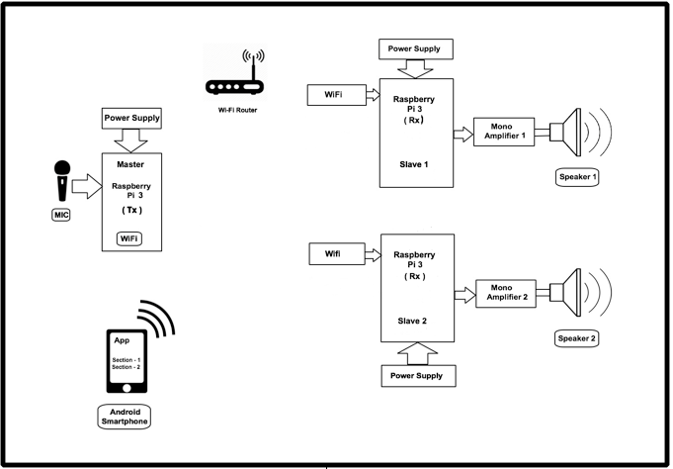

**Figure 3.1: Block Diagram of System**

**3.2 Block Diagram Description**

In Above figure 3.1 system the Wi-Fi router is used to create a LAN Network which is local area network under that network all the system work. There is three raspberry pi is used in Network based wireless PA system, in that two of them is slave which is placed at the anywhere in created network and one is master in Network Based wireless PA system which is present at the input side in other words it is at the user side. For the monitoring purpose there is we are developing the one android app using basic4android development tool which control the network based PA system like volume control whether its volume up or volume down and having one another controlling function and that is turn on slaves or turn off slaves, where user can turn off both slaves at one time or else it will turn off each of them like this type of monitoring is take place using android app.

For broadcasting the voice, music or any audio format we are using the icecast 2 program that will help the system to broad cast the signal in the other networks which is connected to the our WLAN network. The all details related icecast 2 is explain in detail further, at the other side in slave raspberry pi there just open the browsers like chrome browser or uc browser and after that just put the IP address of master raspberry pi and run. In this system we having one advantage and that is multiple device connected in single network and that is access through multiple device just required the source IP address. In WLAN network all the raspberry pi is connected and that will help to use the concept of VoIP tech which is voice over IP, user can play music as well as broadcast anything they want this all system is work under the real time the users voice can transmit through the Wi-Fi network.

The major advantage of this system is that the user can share our audio over a network in other network and it is secured type of communication there is no one can access the private network and there is no noise generate as well as no data loss is take place. Continues voice transition is take place between the both ends.

**3.2.1Raspberry Pi**

The Raspberry Pi is a credit-card-sized computer that plugs into your TV and a keyboard. It is a capable little computer which can be used in electronics projects, and for many of the things that your desktop PC does, like spreadsheets, word processing, browsing the internet, and playing games.Raspberry Pi is an innovative product. The Raspberry Pi is a series of small single-board computers. The Raspberry Pi is an amazing piece of hardware because of the combination of the features of a traditional computer and an embedded device. the Raspberry Pi is an inexpensive computer that can lend itself to many light & medium-duty tasks. Supporting computer operating systems like Linux and providing simple input/output lines i.e. the GPIO makes it perfect for controlling almost anything. Programming the GPIO is much easy and intuitive then an traditional FPGA or microprocessor. The Raspberry Pi is perfect for adaptive technology: it is able to display images or play videos at 1080p high definition resolution to building systems such as digital jukeboxes or prototyping embedded systems. This product makes it possible to build complex and effective products at a cheaper price.

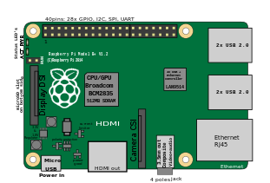

**Figure 3.2.1: Raspberry Pi 3 B**

The Raspberry Pi does not require the user to have extensive programming experience since it is aimed for the younger generation to learn about programming. Python, the programming language that the Pi uses, is less complex than other languages available. For example, it has better code readability and allows the user to type concepts using fewer amount of lines. Python also has an automatic memory management function.The Raspberry Pi is slower than a modern laptop or desktop but is still a complete Linux computer and can provide all the expected abilities that implies, at a low-power consumption level.The Raspberry Pi is open hardware, with the exception of the primary chip on the Raspberry Pi, the [Broadcom SoC](http://www.raspberrypi.org/documentation/hardware/raspberrypi/) (System on a Chip), which runs many of the main components of the board–CPU, graphics, memory, the USB controller, etc. Many of the projects made with a Raspberry Pi are open and well-documented as well and are things you can build and modify yourself.

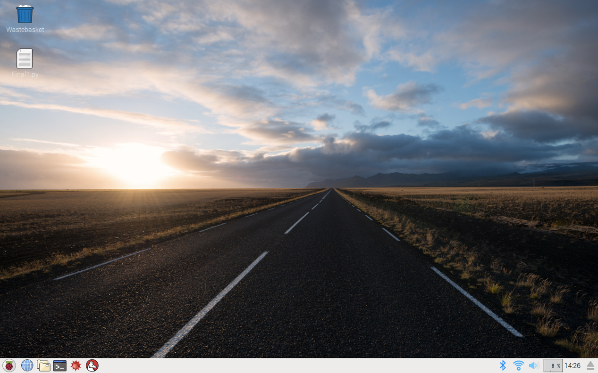

**Figure 3.2.2: Raspberry Pi Desktop**

Raspberry Pi also gives you a lot of room to experiment and turn it into something else that is entirely different.  The SD cards on the board can be easily switched, which allows you to change the functions of the device without spending a lot of time re-installing the software. The Raspberry Pi is a credit-card-sized computer that plugs into your TV and a keyboard. It is a capable little computer which can be used in electronics projects, and for many of the things that your desktop PC does, like spreadsheets, word processing, browsing the internet, and playing games. It also plays high-definition video. We want to see it being used by adults and children all over the world to learn programming and digital making.

As the Raspberry Pi 3 supports HD video, you can even create a media center with it. The Raspberry Pi 3 Model B is the first Raspberry Pi to be open-source from the get-go, expect it to be the defector embedded Linux board in all the forums.Built on the latest Broadcom 2837 ARMv8 64-bit processor the Raspberry Pi 3 Model B is faster and more powerful than its predecessors. It has improved power management to support more powerful external USB devices and now comes with built-in wireless and Bluetooth connectivity. To take full advantage of the improved power management on the Raspberry Pi 3 and provide support for even more powerful devices on the USB ports, a 2.5A adapter is required. Technical Specifications: - Broadcom BCM2837 64bit ARMv8 QUAD Core 64bit Processor powered Single Board Computer running at 1.2GHz, 1GB RAM, BCM43143 Wi-Fi on board, Bluetooth Low Energy (BLE) on board, 40pin extended GPIO, 4 x USB2 ports, 4 pole Stereo output and Composite video port, Full size HDMI, CSI camera port for connecting the Raspberry Pi camera, DSI display port for connecting the Raspberry Pi touch screen display,Micro SD port for loading your operating system and storing data, Upgraded switched Micro USB power source (now supports up to 2.5 Amps) This product is made under license in both China and the U.K. Please see the product packaging.

**3.2.2 Amplifier**

An amplifier is an electronic device that increases the voltage, current, or power of a signal. Amplifiers are used in wireless communications and broadcasting, and in audio equipment of all kinds. They can be categorized as either weak-signal amplifiers or power amplifiers. Weak-signal amplifiers are used primarily in wireless receivers. They are also employed in acoustic pickups, audio tape players, and compact disc players.

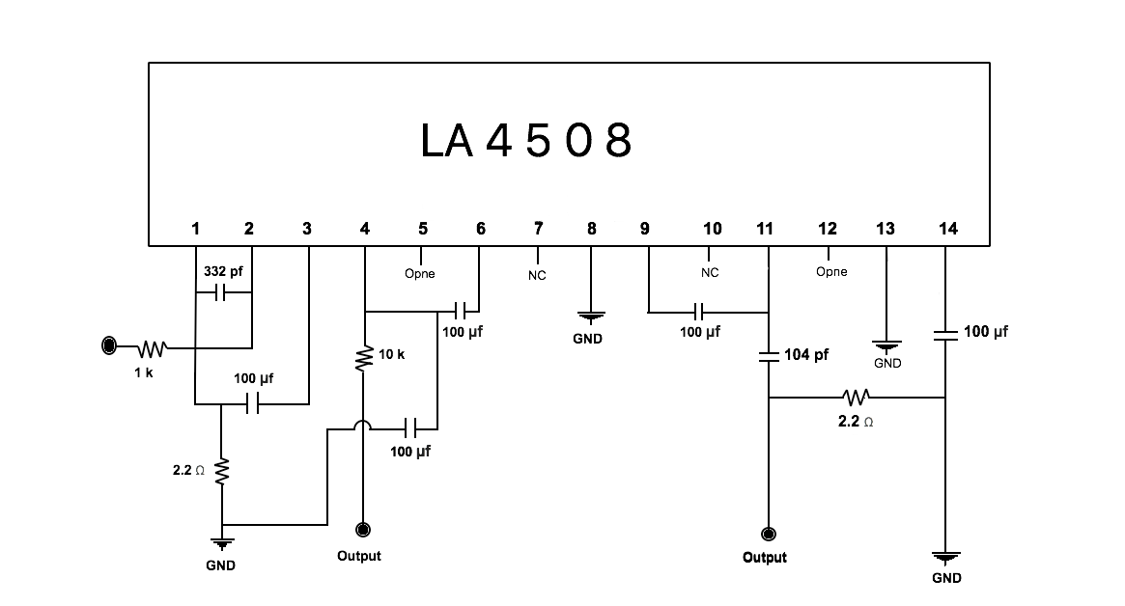

**Figure 3.2.3: Circuit Diagram of Amplifier**

A weak-signal amplifier is designed to deal with exceedingly small input signals, in some cases measuring only a few nanovolts (units of 10-9 volt). the basic functionality is to receive an audio signal, amplify the audio signal, and allow pass-through of the corresponding video signal to a display device such as a projector or a television. Mono amplifiers are used in wireless transmitters, broadcast transmitters, and hi-fi audio equipment. The most frequently-used device for power amplification is the bipolar transistor. However, vacuum tubes, once considered obsolete, are becoming increasingly popular, especially among musicians. Many professional musicians believe that the vacuum tube provides superior fidelity. An amplifier can either be a separate piece of equipment or an electrical circuit contained within another device. Amplification is fundamental to modern electronics, and amplifiers are widely used in almost all electronic equipment. Amplifiers can be categorized in different ways. One is by the frequency of the electronic signal being amplified. Two important considerations in power amplification are power output and efficiency. the basic functionality is to receive an audio signal, amplify the audio signal, and allow pass-through of the corresponding video signal to a display device such as a projector or a television.

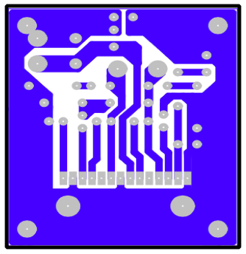

**Figure 3.2.4: PCB Layout of Amplifier**

This mono amplifier uses low cost, and widely available components. With the addition of a few passive components it is possible to build a low cost mono amplifier featuring a good impulse response, ideally suited for connection to a small speaker. The project here features a simple design for easy construction; it is relatively inexpensive. The design is based on a LM4508. The amplifier system been described here produces 20 Watt power at very low distortion.

The described Amplifier has inputs for audio sources such as CD player, MP3 player and FM/AM signals. Other controls for the described amplifier system are Bass, Treble and Volume control. The amplifier puts out a surprising amount of power, considering that it runs from a 12V AC 2A transformer. One reason this system performs so well is that it is based on the National Semiconductor LM4508 20W audio amplifier IC. This IC has inbuilt thermal protection so that even if you abuse it or short out its output, it won’t be damaged.

**3.2.3 Wi-Fi Router**

A wireless router is a device in a wireless local area network(WLAN) that determines the next network point to which a packets should be forwarded toward its destination. A wireless router works in the same way as the router in a hard-wired home or business local area network (LAN), but allows greater mobility for notebook or portable computers.

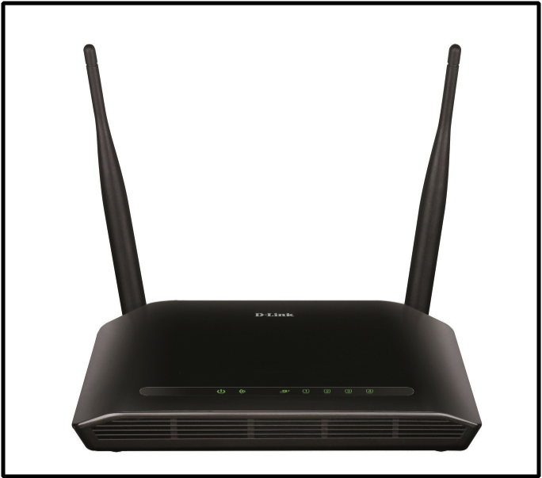

**Figure 3.2.5: Wi-Fi Router**

The individual computers are equipped with small wireless transceiver that can be plugged into either a Universal Serial Bus USB or a PC Card slot.A wireless router is a device that performs the functions of a router and also includes the functions of a wireless access point. It is used to provide access to the Internet or a private computer network.

Instead of cabled routers which used to be the norm, a wireless router will receive the internet data through the phone line and then convert that data into radio signals. These signals are then picked up by the network card in your computer, smartphone or games console and transmitted into internet data again. To establish Wi-Fi in your area, all you need is either a modem connected to a wireless router, or a wireless gateway, which is a modem and wireless router in one unit. A Wi-Fi-capable device can then use this signal to connect to the Internet.Instead of cabled routers which used to be the norm, a wireless router will receive the internet data through the phone line and then convert that data into radio signals. These signals are then picked up by the network card in your computer, smartphone or games console and transmitted into internet data again.

In order for devices on the network to connect to the Internet, the router must be connected to a modem. Therefore, most routers have a specific Ethernet port that is designed to connect to the Ethernet port of a cable or DSL modem. A modem is a device that provides access to the Internet. The two major components in a small computer network are a modem (cable or DSL) and a wireless router. The router is wired to the modem, and the modem is wired to the cable company's coaxial cable or the telephone company's DSL phone line. For Internet access via satellite, the router is wired to a satellite modem. There are a few easy ways to check if your modem has a built-in router. Ethernet ports – If your modem includes Ethernet ports on the back, it also doubles as a router, though this does not guarantee it supports Wi-Fi. Wi-Fi light Most wireless devices include an LED that indicates Wi-Fi is turned on and functioning.

**3.2.4Microphone**

A microphone is a transducer that converts sound into an electrical signal. A microphone is a device that captures audio by converting sound waves into an electrical signal. This signal can be amplified as an analog signal or may be converted to a digital signal, which can be processed by a computer or other digital audio device.Microphones are used in many applications such as telephones, public address systems for concert halls and public events, production, live and recorded audio engineering, sound recording, two-way radios, radio and television broadcasting, and in computers for recording voice, speech recognition, VoIP.

* Noise Cancelling For Microphones Record Clean And Clear Sound For Professional Results.
* Perfect Sound: Omni Directional Condenser Adopts Material To Reach Strong Noise Cancelling Effect, No Matter Outdoor, Walking On The Street, In The Windy Weather, You Can Get Clean And Clear Voice
* High quality design fit voice chat, video conferencing, voice recording, gaming, Use ForYouTube Podcasting, Garageband, Or Even To Record Your Own Rap!
* Clip-on design, easy to clip it to your shirt, collar or placed in small pockets
* 3.5mm plug, compatible with PC, desktop, laptop, MP3, MP4, Camera, Video.

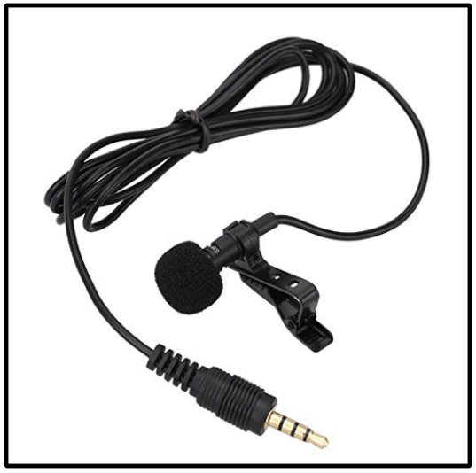

**Figure 3.2.6: Microphone**

Microphones enable many types of audio recording devices for purposes including communications of many kinds, as well as music and speech recording.Frequently, microphones are designed for a given purpose. One of the main considerations, aside from the type of device, is what is being recorded. Directionality of microphones is one such consideration in microphone design. Omnidirectional microphones are suited to recording all sounds in an area but poor for focusing on a single subject amongst background noise. Directional, bidirectional and shotgun microphones are suitable for interviews. However, the same effect is often achieved with two unidirectional devices, such as cardioid microphones.

**3.2.5 Audio/Sound Card**

The Raspberry Pi has an on-board audio jack, which is super handy for all kinds of sound effects and speech, just plug and go. However, for when you want better audio for music playback, a USB audio card can greatly improve the sound quality and volume. A sound card also known as an audio card is an internal expansion card that provides input and output of audio signals to and from a computer under control of computer programs. The term sound card is also applied to external audio interfaces used for professional audio applications.Almost all new computers come with built-in soundcards. These soundcards work to convert electronic signals into audio output through your computer's speakers or headphones. Even with built-in soundcards, users may opt to use externalized USB sound cards.

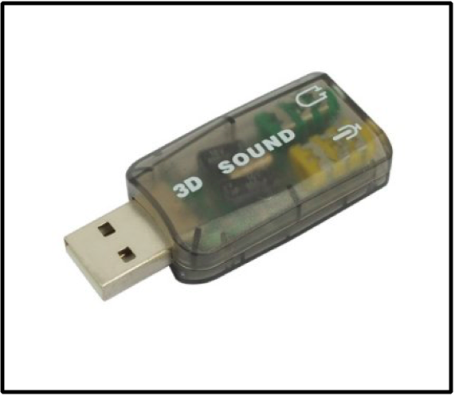

**Figure 3.2.7: Sound/Audio Card**

Basic USB sound cards are inexpensive and easier to install than internal sound cards, making them an ideal upgrade in certain situations.USB soundcards can have basic or advanced functions. Some USB cards are no bigger than a pen-drive, containing only simple microphone and headphone jacks; other soundcards feature miniature mixing boards, XLR ports, equalizers and 1.4-inch jacks for professional recording.Typically, external soundcards are bought cheaply with basic features, allowing for a quick fix to a malfunctioning or poor quality onboard soundcard. Less frequently, expensive models are purchased for USB-based professional recording.USB sound cards are usually compatible with almost any PC and, in many cases, even Macs. As a USB device, most external soundcards feature "plug-and-play" technology for convenient sharing among multiple computers.The USB connection offers one channel of digital bits, the computer’s language of 1’s & 0’s, to be sent and received from the box. The sound card then has to decipher the data and decide what to do with it. The sound card translates everything for us.

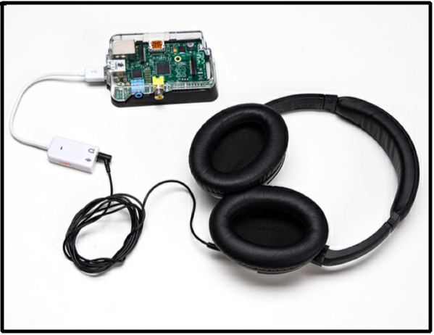

**Figure 3.2.8: Sound Card Connected With Pi**

  A portable sound card for your pi or desktop. With this USB sound card we can listen to your favourite songs and also enjoy your movies. The usb sound card does not require any installation and thus saves you the trouble of finding the driver and making sure that it is compatible with your system. The USB sound card from Quantum is a portable device that does not require a power source or charging, unlike most other external sound-cards. This is a plug and play device which is USB powered so you do not have to worry about battery replacement either. It is a very small device which makes it convenient as well. we can carry this sound card with us wherever we go. There is a digital class B power amplifier inside this small product that enhances the sound quality of any device to which it is connected. Like other sound cards, this small but effective sound card has one port for the speakers and one for the mic. It also supports 3D positional sound. The virtual 5.1 channel soundtrack allows you to connect a 5.1 speaker system and enjoy the experience of a live concert or a movie theater. The mic input of this sound card allows you to connect your headset to it and video chat with your friends and family.

Typical uses of sound cards or sound card functionality include providing the audio component for multimedia applications such as music composition, editing video or audio, presentation, education and entertainment (games) and video projection. Sound cards are also used for computer-based communication such as voice over IP and teleconferencing.

**3.2.6 SD Card**

A memory card, flash card or memory cartridge is an electronic flash memory data storage device used for storing digital information.

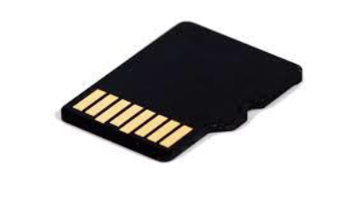

**Figure 3.2.9: SD Card**

These are commonly used in portable electronic devices, such as digital cameras, mobile phones, laptop computers, portable media players. Secure Digital (SD) Card is a non-volatile memory card format developed by the SD Card Association (SDA) for use in portable devices. SD card is used to store OS, Program and user data. Storage Capacity is 16GB.

**CHAPTER 4**

**PROJECT METHODOLOGY**

**4.1 SOFTWARE**

**4.1.1. ICECast2**

ICEcast is a streaming server which allows radio stations to effectively broadcast audio online this is known as webcasting. It is powerful and stable, meaning you can throw all of your internet radio traffic at it without having crashes or other problems. Audio listeners can access the stream through any live MP3 supported media player. ICEcast has mount points meaning and automatically transfers listeners from the Auto DJ to the Live stream and back again without needing to manually turn anything on or off. There are 3 stages to the broadcasting process. You don’t need any complicated or expensive software or hardware at your end either, a simple desktop PC and broadband connection will work fine. ICEcast is an industry standard platform used by thousands and thousands of radio stations all over the world. Its wide compatibility means people can listen with most players and operating systems.

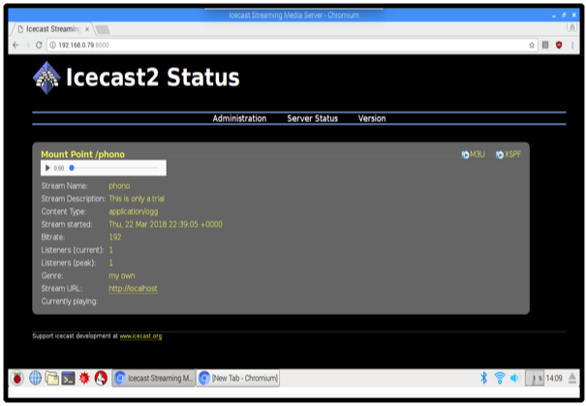

**Figure 4.1.1:ICEcast2 Status**

Listeners will be able to connect to your MP3 stream from all over the world, with all the popular media players including Windows Media Player, iTunes, Win amp, Real player, XMMS, and many more media players besides.Although incredibly simple, it can cope with even the heaviest demands and will not break under pressure. Its simplicity works to the broadcaster and listeners favour.ICEcast is actually very simple to use. You can use free software like Win amp to broadcast, which can be installed on any internet connected Windows computer. There are also solutions available for Apple and Linux users. You can also consider using tools such as Simple cast and SAM Broadcaster, these are more professional and 100% ICEcast compatible tools.

ICEcast has mount points which means it automatically transfers listeners from the Auto DJ to the Live streaming and back again without having to manually turn anything on or off. So you connect and all the listeners are transferred from the autodj to the live streaming and then back again when you are finished. This, unlike WHM Sonic works with MP3 streams so it works with any media player ie. Windows Media, Real Player, I-Tunes, Win-Amp, even flash players. ICEcast Hosting Servers is similar to Shout cast in many ways, however allow you to stream using MP3, Ogg, Aac+ or Opus supported media.All ICEcast Hosting Packages will include Free Auto DJ. Our autodj system will allow you to upload your mp3’s to the system and to be able select multiple playlists and stream 24/7 without having your computer on all the time.

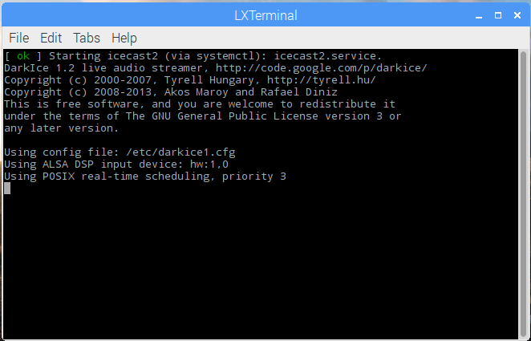

**Figure 4.1.2: ICEcast 2 Programming Window**

Icecast2 is a free audio streaming server which supporting the shout cast protocol. MPD is a music player daemon which serves as a backend for playing audio. MPD uses the shout cast library to stream to icecast2. Fortunately, Raspbian MPD is compiled with libshout and also mp3 support by default so we don’t have to build any custom packages. MPC is a command line client to control MPD, for example to manage playlists or to start/stop playing a song.

Icecast2 is a streaming media audio and video over server which supports Ogg and MP3 audio format for streams. It can be used to create an Internet radio station or a privately running jukebox. ICEcast2 is a streaming server which allows radio stations to broadcast audio online and this is known as webcasting also. It is most powerful and stable, it means you can throw all of your internet radio traffic at it without having any problem or crashes. Audio listeners can access the stream through any live MP3 supported media player using IP address of sources audio transmission. ICEcast2 has many points meaning and automatically transfers listeners from the Auto DJ to the Live stream and back again without needing to manually turn on or turn off. The user can easily access the the any audio from anywhere in the LAN network Through the ICEcast2.

**4.1.2 Python**

Python is an interpreted, object-oriented, high-level programming language with dynamic semantics. Its high-level built in data structures, combined with dynamic typing and dynamic binding, make it very attractive for Rapid Application Development, as well as for use as a scripting or glue language to connect existing components together. Python's simple, easy to learn syntax emphasizes readability and therefore reduces the cost of program maintenance. Python supports modules and packages, which encourages program modularity and code reuse. The Python interpreter and the extensive standard library are available in source or binary form without charge for all major platforms, and can be freely distributed. Python is a wonderful and powerful programming language that's easy to use (easy to read and write) and with Raspberry Pi lets you connect your project to the real world.

Python syntax is very clean, with an emphasis on readability and uses standard English keywords. Start by opening IDLE from the desktop. Raspbian comes preloaded with Python, the official programming language of the Raspberry Pi and IDLE 3, a Python Integrated Development Environment.

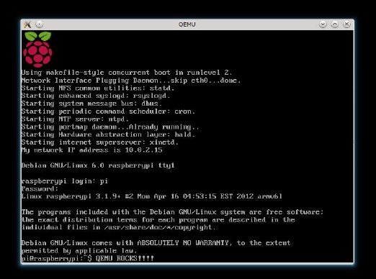

**Figure 4.1.3: Initial Booting Of Raspberry Pi**

Debugging Python programs is easy: a bug or bad input will never cause a segmentation fault. Instead, when the interpreter discovers an error, it raises an exception. When the program doesn't catch the exception, the interpreter prints a stack trace. A source level debugger allows inspection of local and global variables, evaluation of arbitrary expressions, setting breakpoints, stepping through the code a line at a time, and so on.

* + 1. **Basic4Android**

Basic4Android has an Open Source License, so it is a free framework for mobile app development. It has a large community of developers for assembling new codes and modules to improve the quality of the apps built. One of the major benefits of Basic4Android is that it can be used for creating a single app that works on all mobile devices. It works on HTML5, CSS3, and JavaScript. Applications developed using Basic4Android work uniformly well over multiple platforms rendering the same look and feel. Moreover, the powerful backend system increases the speed of development of mobile apps. Another amazing feature of the tool is that it taps into the hardware of the device such as the camera, accelerometer, geo-location, etc.

Basic4Android currently known as B4A is a rapid application development tool for native Android applications, developed and marketed by Anywhere Software Ltd. B4A is an alternative to programming with Java. B4A includes a visual designer that simplifies the process of building user interfaces that target phones and tablets with different screen sizes. Compiled programs can be tested in AVD Manager emulators or on real Android devices using Android Debug Bridge and B4A Bridge The language itself is similar to Visual Basic and Visual Basic .Net though it is adapted to the native Android environment.B4A is an object-based and event-driven language.

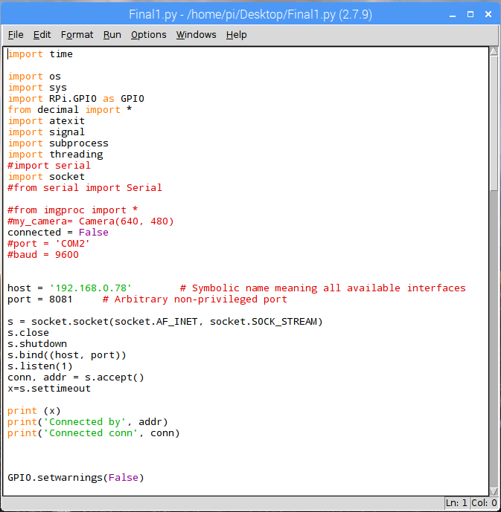

**Figure 4.1.4:Basic4Android App Running Program Window**

B4A generates standard signed Android applications which can be uploaded to app stores like Google Play, Samsung Apps and Amazon Appstore. There are no special dependencies or runtime frameworks required.

Basic4Android is a coding environment and language that lets you code Android apps using BASIC (Beginners All-Purpose Symbolic Instruction Code). For non-programmers out there this means it’s a full programming language not an ‘app builder’. It’s also worth noting that there are no limitations to using this environment. People build computer games with it, I’ve built a launcher, and if you want to you can add your own libraries in Java. So literally there’s nothing you can do in Eclipse with Java that you can’t do with Basic4Android. It’s just quicker.And for beginners You have three options. Option one is to pay someone to build you an app, Option two is to use an ‘app builder’ which is super limiting only really useful if you want to build an app that’s a static page of text. Lastly, option three, is to learn to program. Basic4Android is the perfect jumping on point however it’s quick, light and easy but it’s an introduction to real programming with everything that entails. There’s also a designer to make it easy to create the UIs for your apps, and a super helpful community as mentioned earlier.

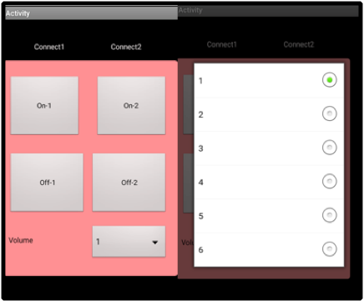

**Figure 4.1.5: Actual View of Android App**

Basic4Android has an Open Source License, so it is a free framework for mobile app development. It has a large community of developers for assembling new codes and modules to improve the quality of the apps built. It is a robust tool for building apps without possessing any special skill set or expertise.Basic4Android allows any user to create and share their own libraries which are written in Java. Any code you can use with Android Studio you can wrap into a library for B4A. And if you can’t, there’s probably someone on the forum who will do it for you. Basic4Android is an IDE (integrated development environment) and ‘RAD’ tool (rapid application development). As that title suggests, the aim is to facilitate the fast and easy creation of apps. At the same time, it tries to do this without limiting you in any way as far as what your programs are capable of.

It’s also worth noting that there are no limitations to using this environment. People build computer games with it, I’ve built a launcher, and if you want to you can add your own libraries in Java. So literally there’s nothing you can do in Eclipse with Java that you can’t do with Basic4Android. It’s just quickerAnd for beginners You have three options. Option one is to pay someone to build you an app, Option two is to use an ‘app builder’ which is super limiting only really useful if you want to build an app that’s a static page of text. Lastly, option three, is to learn to program. Basic4Android is the perfect jumping on point however it’s quick, light and easy but it’s an introduction to real programming with everything that entails. There’s also a designer to make it easy to create the UIs for your apps, and a super helpful community as mentioned earlier.

* 1. **IMPLEMENTATION OF SYSTEM**

**4.2.1 Design Flow**

1. The proposed system aims are streaming the voices in real time using Wi-Fi network or LAN network.
2. Initialize The LAN Network through Wi-Fi router and all other device is connecting to this network which is work under this system.
3. First up on the user will speak on microphone which is present at input side of system.
4. The mic will convert that signal and give it to the raspberry pi with help of audio card.
5. Raspberry pi will process that data in the form of packets and after that the data is stream with the help of ICECast 2 softer tool as we earlier discus, this data is transmitting one raspberry pi to other raspberry pi at other end.
6. At the receiver side we can access the stream voice data using the IP address of transmitter raspberry pi, open the any Brower and put the url as IP address of transmitter raspberry pi.
7. After that the user can heard the streaming audio at the receiver side that is connected to the nono amplifier with speaker.
8. Android app is developed to controlling the receiver side it controls the volume up as well as volume down and also turn off and turn on the receiver sides raspberry pi.
9. This all about the design of system.
   1. **Algorithm of System**
10. Start
11. initialize Wi-Fi router
12. initialize the Raspberry Pi
13. initialize the Sound card
14. connect Smartphone to LAN network
15. Input form User
16. Convert the user Voice in code
17. process the data using raspberry pi
18. Broadcast the data using ICECast 2
19. Stream the data over the LAN Network to the other end
20. Data will receive and provide the output upon the revive data
21. Android can control the volume and system on-off
22. Store data in sd card

**4.4 Flow chart of System**

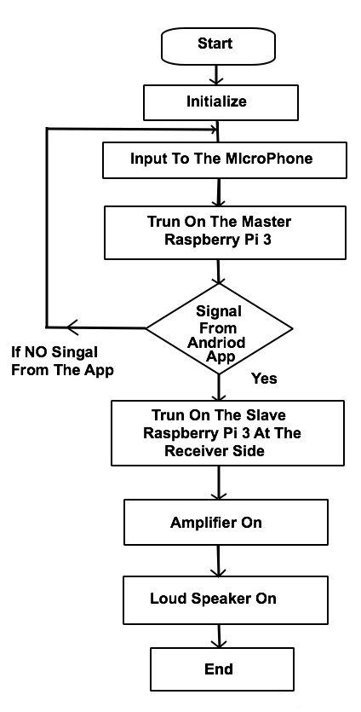

**Figure 4.4 : Flowchart of the proposed system**

**CHAPTER 5**

**IMPLEMENTATION RESULT**

From the above mentioned information about the system we can conclude that the Network Based Wireless PA System having two main objectives in Wireless PA System that is Broadcasting of controlling the receiver side. The System response is as follow

**5.1 ICECast 2 Broadcasting**

**Step 1 –** First upon configure the icecast2 setup in the raspberry pi. After the configuration done the program of icecast2 is execute in the terminal of the raspberry pi.

.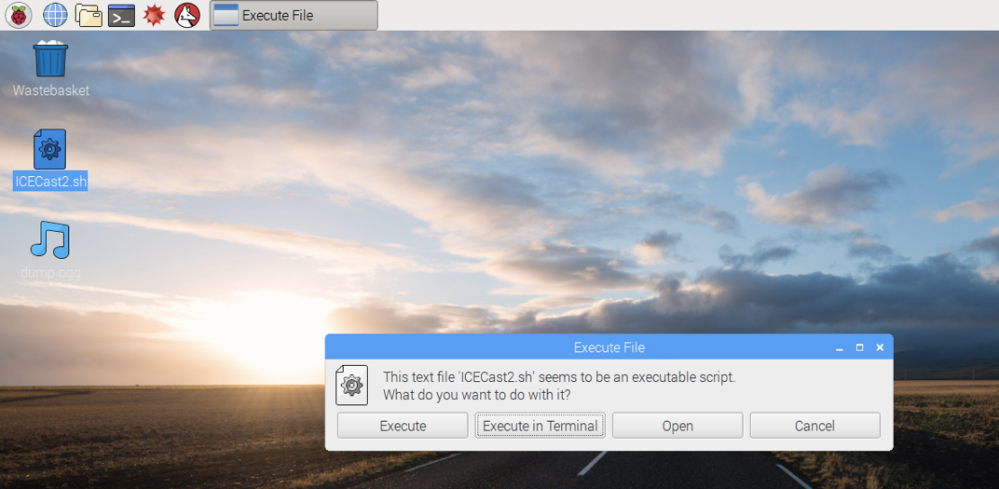

**Figure 5.1.1 : ICECast2 Program**



**Figure 5.1.2: ICECast2 Execute in Terminal**

**Step 2 –** after that the icecast start broadcasting the users voice over a network. At the receiver side just open a browser and write the IP Address of the transmitter raspberry pi.

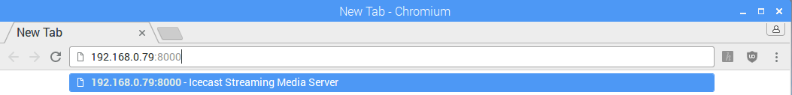

**Figure 5.1.3 : IP Address Write In URL**

**Step 3 –** Now once we write the IP address of receiver sides than the ice cast window will open its look like the below in figure 5.1.1 just click on the play button and the broadcasting is start.

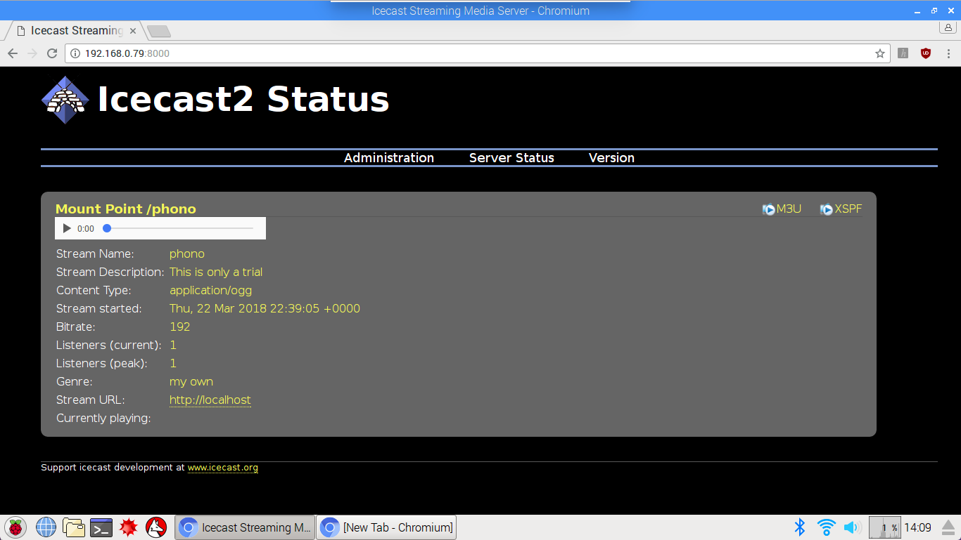

**Figure 5.1.4: Broadcasting Start In Raspberry Pi**

**Step 4 –** The user can access the broadcasting using the mobile phone just open the any browser and just the put IP address in url.

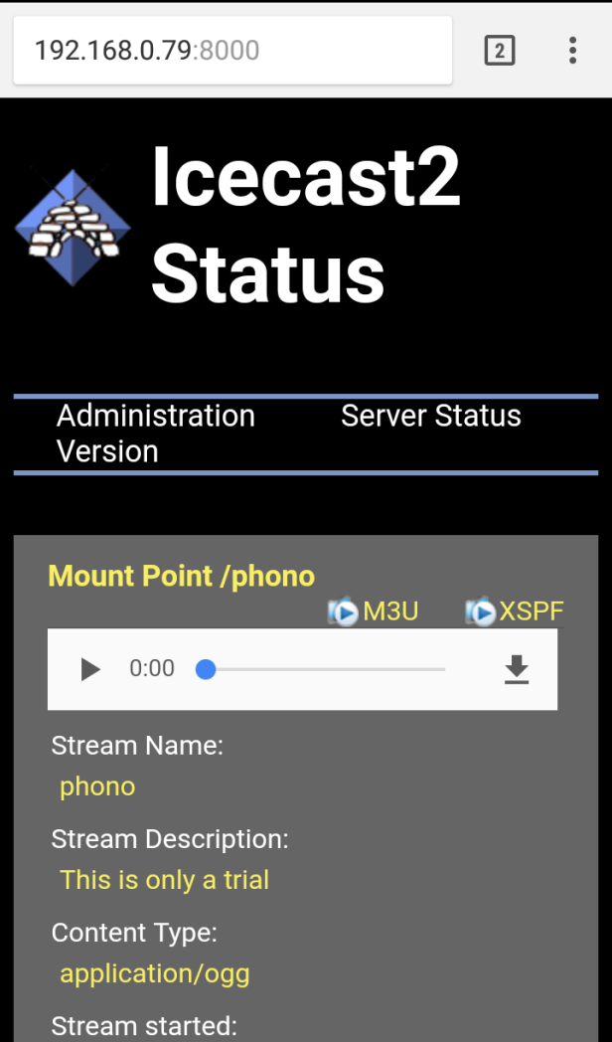

**Figure 5.1.5: Broadcasting Start In Mobile**

**5.2 Android App**

**Step 1**- Execute the android app program in the terminal of the raspberry pi. Once program is run than it will connect with the android app with the help of network.



**Figure 5.2.1: Program for Android App**

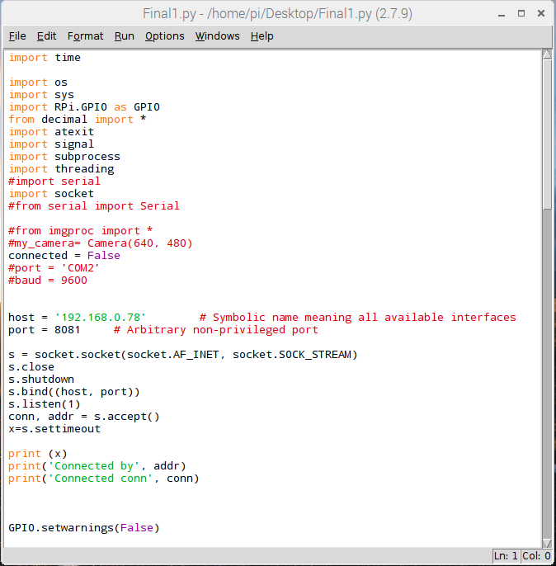

**Figure 5.2.2: Execute program in terminal**

**Step 2 –** Open Android App and it will automatically connect to the system through the LAN network. There two controlling mode in the android app one is volume which is 1 to 6 and turn on 1 & 2 and turn off 1 & 2 this 2 controlling function is present in android app.

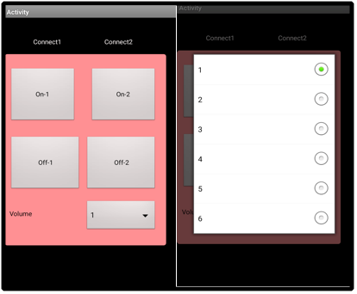

**Figure 5.2.3: Controlling Options in Android**

**CHAPTER 6**

**CONCLUSION**

**6.1 Conclusion:**

In this phase of the project, a secure connection, with the help of VOIP and SIP protocol, was established between three Raspberry Pi devices with a Wi-Fi connection. With the help of this connection, voice was recorded, played and streamed on and from one Raspberry Pi to another raspberry pi module using a Python based GUI successfully. And controlling the receiver side with the help of android app. The attempt to live audio transmission between two raspberry pi modules was successfully achieved through VOIP server/client implementation maintaining operation of Raspberry Pi as a headless embedded system. The usage of open source, freeware programs and OS kept the project cost low.

**6.2 Future Scope:**

The system can be made more efficient by adding following features:

1. Two of the most prolific recent advances in audio technology, at least from a hardware point of view, are noise-cancellation and wireless connectivity in professional and consumer headphones and earphones.
2. These technologies have become commonplace over the past five years or so in the way people listen to music or use audio devices to communicate. Bluetooth has only recently reached a level where it is considered by OEMs as good enough to carry quality audio and replace wires completely, thus paving the way for a throng of cable-free cans.
3. We are now also starting to see noise-cancellation features in these wireless devices to offer the best of both worlds, allowing users to block out external, unwanted sounds and concentrate solely on the music without being tied to a device. Still, at the moment, a bog standard set of earphones that the average person buys from Amazon, for example, will still most likely be wired. This is going to be one of the first big changes in audio technology in the coming years.

**References**

1. Rajeeb Lochan Dash, Mrs. A. Ruhan Bevi,” Real-time Transmission of Voice over 802.11 Wireless Networks Using Raspberry Pi” IJEDR 2014.

2.S.Sundar D.C.E, M. Krishna Kumar, P.Selvinpremkumar,M.Chinnadurai,“Voice Over Ip Via Bluetooth/Wi-Fi Peer To Peer”, Ieee Paper, March 30, 31, 2013.

3. Matt Richardson, Shawn Wallace, "Getting Started with Raspberry”, Brian Jepson, O'Reilly Media Inc., United States of America, first edition, pp.10-31,December 2012.

4. Yingjie He, Liwei Ding, Yuxian Gong, Yongjin Wang, “Real-time Audio & Video Transmission System Based on Visible Light Communication”, Optics and Photonics Journal, 2013.

5. Daniel Jakubisin, Marshall Davis, “Real- Time Audio Transceiver Utilizing 802.11b

Wireless Technology”, IEEE 2007.

6. Wenbo Zhai,Jian Wang,"An Application of VoIP Communication on Embedded System",International Conference on Computer Application and System Modeling (ICCASM),2010.

7. Arun Biradar,Dr. Ravindra C. Thool, Dr. Rajappa Velur,"Voice Transmission over Local Area Network Using Bluetooth", IEEE, 2009.

8. Bhushan R., "Proposed System for Placing Free Call over Wi-Fi Network Using VoIP and SIP", Jichkar Int. Journal of Engineering Research and Applications, ISSN:2248-9622, Vol. 4, Issue 1( Version 3), January 2014, pp.132-135.

**6.4Websites**

1. [www.google.com](http://www.google.com)
2. <https://www.raspberrypi.org/downloads/raspberry-pi-desktop/>
3. <https://stmllr.net/blog/streaming-audio-with-mpd-and-icecast2-on-raspberry-pi/>
4. <https://en.wikipedia.org/wiki/Amplifier>
5. <https://en.wikipedia.org/wiki/Voice_over_IP>

**Datasheets**

* Raspberry Pi 3 B
* Datasheet LM 4805
* Wi-Fi Router